Sharks and Minnows

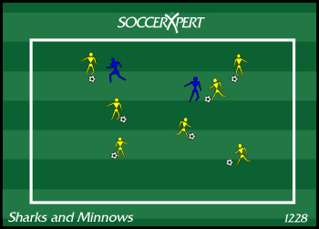
Drill Objective:
This drill focuses on the U6 and U8 player and their ability to dribble out of pressure. This drill can be used to focus on the player using their body to protect the ball by placing their body in between the ball and the defender.

Drill Setup:
- Build a grid approximately 20X25 yards. This field should be adjusted based on the skill level and number of players participating.
- Two players are designated the SHARK start in the middle of the grid without a ball.
- The remaining player starts with a ball on one of the end lines.

Drill Instructions:
- The minnows, the players with the ball, attempt to swim from one end line to the other while keeping their ball away from the sharks.
- The sharks attempt to gain possession and knock the minnows ball out of the grid. Once this happens, the minnow becomes a shark.
- The last minnow standing wins the competition.

Drill Coaching Points:
- Keep the dribblers under control and not paniced once the sharks get near them.
- Inform players to keep the ball close within playing distance.

Drill Variations
- Players only use left foot to dribble.
- Players use outside of feet to dribble.
- Players use sole of feet to dribble.

